**Summary of McDonald's Sales**

As we can see **Burger , Chicken and Pasta** tends to have more sales revenue as compared to other . They hold the position **1st** , **2nd** and **3rd** respectively . We should focus on more on Chicken and Pasta as they can generate more profits with less quantity sold , because there price is more then burger .

We can see that there are more orders on weekdays as compared to weekends , **Monday** holds the **1st** position with 2010 orders , Friday holds the **2nd** position with 1822 orders and **Tuesday** holds the **3rd** position with 1788 .

Most Ordered item is Side Salad with 631 orders .

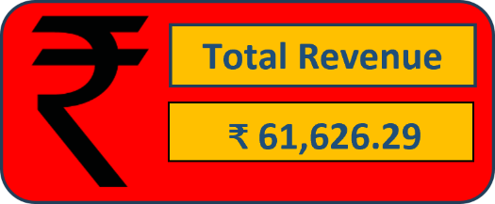

Sales generated revenue of **₹ 61,626.29** .

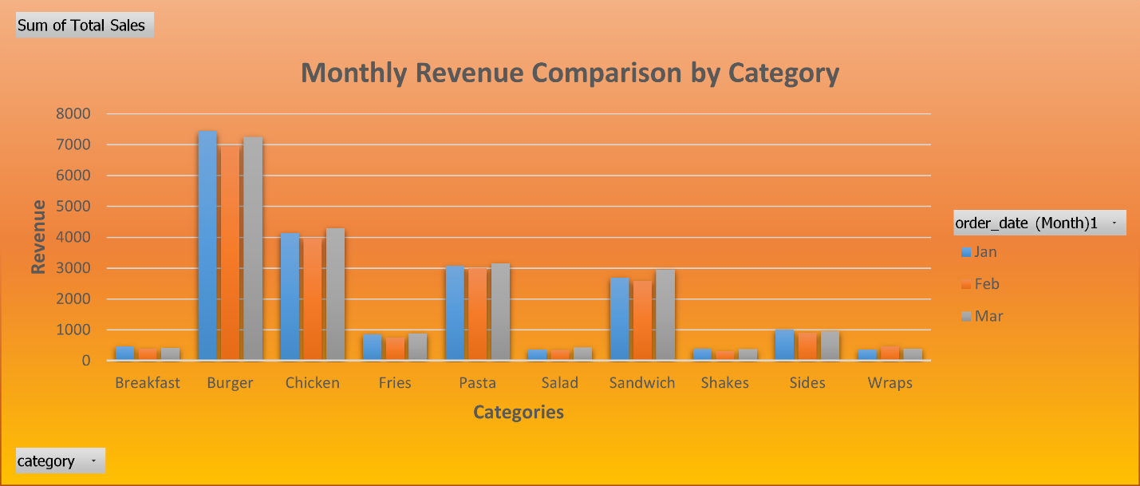

As we can see January month has generated more revenue in Burger category as compared to other month followed by March and February .

The **average no. of items per order** is **2.28** which can be **3** If provide some discount on items like chicken and salad combo .

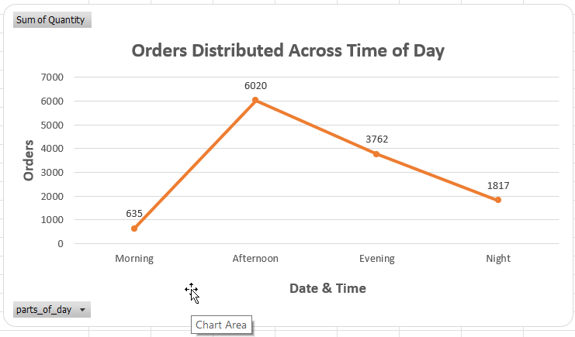

There are more no. of orders in Afternoon with 6020 , followed by Evening with 3762 and at last Night , meaning the customer are more coming to have Lunch at the McD .

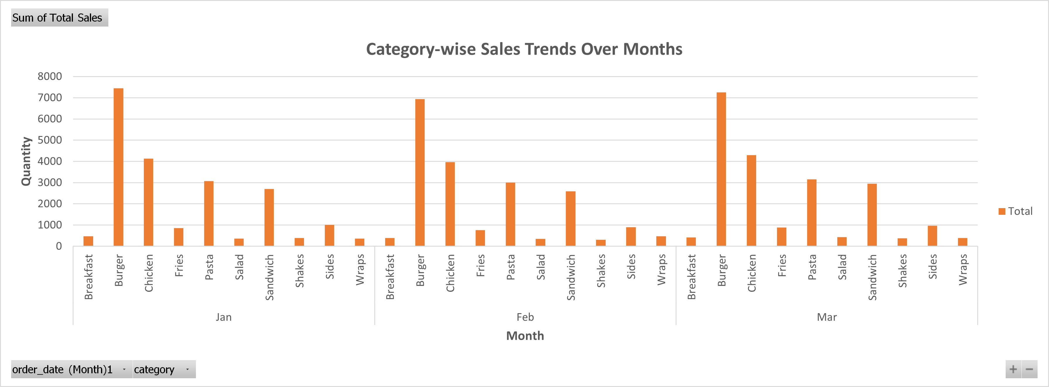

As we can see January month has generated more revenue in Burger category as compared to other month followed by March and February .

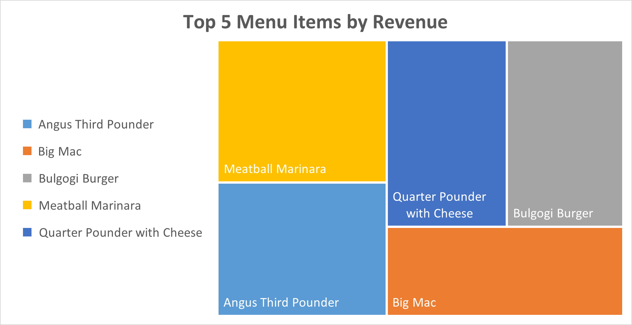

We can see the top 5 menu items which generate more Revenue to the restaurant .